CP2403/CP3413: Project – Part 2 – 30% - Answer Template
Data Analytics & Statistical Modelling
Due: (Friday, 10 April 2026 – Week 10 Friday)

First Name: Jack
Last Name: Kelly

Task 1: ANOVA Analysis

Investigative Question:
Do ammonia micromole levels (NH3uM) at a certain depth vary based on quality code (RecInd) in the last year?

Variables Selected:
- Categorical variable: Micromoles Ammonia per L of seawater (NH3uM)
- Quantitative variable: Bottle Quality Code (RecInd)

Step 1 - Hypothesis
Null hypothesis (H_{o}): There is no correlation between quality code and ammonia levels

Alternative (H_{a}) hypothesis: Quality code affects the ammonia level reading, giving skewed data.

Step 2 - Data Processing Summary (approx. 80 words)
- Filtering applied:
To get a more focused set of data, readings from only the last year of recording (2021), were grabbed. The categorical data for bottle quality was also recoded from simple integers to the actual meanings of the readings. The depth was also normalized to around the 10m mark. This should mean that there isn’t too large a variation in the readings should depth play a factor.

- Missing value handling:
NaN values were dropped where the ammonia readings were blank to avoid any issues with the results.

- Any transformation (e.g. grouping variable into categories)
None

- Rows remaining after cleaning:
160 rows were left after this cleaning.

Insert screenshot of .head() or summary output after preprocessing
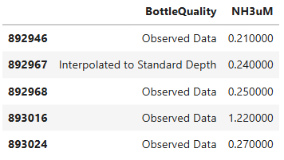

Step 3 – ANOVA Test Results
- F-statistic:
0.2493
- p-value:
0.618
- Group mean values:
Interpolated to Standard Depth 0.145333
Observed Data 0.123391
- Standard deviation values:
Interpolated to Standard Depth 0.282228
Observed Data 0.236294

Insert ANOVA table screenshot if available.
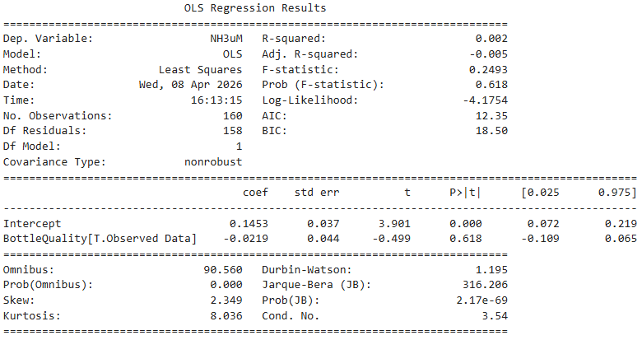

Step 4 – Visualization
Insert Box Plot showing group comparison
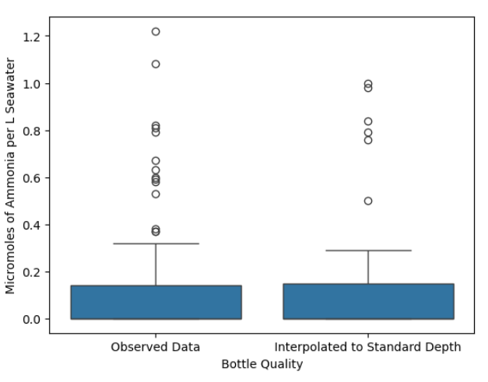

Analytical Reflection (approx. 120-180 words)
- Observed pattern or statistical result
The pattern here is deceptive. Initially, it can be seen that the averages vary slightly, going from observed data at 0.12 micromoles on average, to 0.15 micromoles when interpolated. This could indicate that the interpolated data is always higher than the general real reading from the ammonia levels. We also see that the standard deviation is quite high for both readings, both sitting over 0.2 micromoles. This disproves a strong relationship – and is only pushed by the p value which sits at 0.618, a very high reading which further relinquishes the chances of a relationship, alongside the box plot seen, where both have the bulk of their values (seen in blue) between 0-0.2 micromoles – appearing practically identical.

- Interpretation of result
Essentially, with the real data values presented, it’s clear that the initial idea that the interpolated data gives higher readings, is false. In this instance, with the high p values and varying deviation results, we can only accept the null hypothesis; that there is no correlation between quality code and ammonia levels, when there may appear to be at a first glance.

- Impact of preprocessing
Sticking to just one year certainly gave a more focused group of data, however, it may have affected the variation in data. Though it probably wouldn’t have affected the result, we may have seen more values in the categorical section – perhaps more than two outcomes.
- Limitation or alternative analysis
To give a better result next time, perhaps comparing data that was collected over a greater length of time (giving more data) would give a more in-depth analysis as to the effects of a ‘bad sample.’

Task 2: Chi-Squared Test

Investigative Question:
Do different depth ‘levels’ (<40, <110, >=110) give different ‘levels’ of o2 saturation (low, medium, high, very high)?

Variables Selected:
- Categorical variable 1: recorded depth (R_Depth)
- Categorical variable 2: Oxygen Saturation (O2Sat)

Step 1 - Hypothesis
Null hypothesis (H_{o}): The depth of the sample has no bearing on the recorded oxygen saturation

Alternative (H_{a}) hypothesis: The oxygen saturation varies in accordance with the samples’ depth.

Step 2 - Data Processing Summary (approx. 80 words)
- Filtering applied:
Here, a max depth was applied to dissociate outliers from the data. The depth levels were then grabbed alongside the oxygen saturation to give the data required for this analysis.

- Missing value handling:
Missing values were exempt from the data as they would not prove useful for this use case. This was done with a basic ‘dropna’ of ‘depthlevels’ and ‘saturationlevels’

- Category grouping (if any)
There is a distinct lack of varying categorical data in this dataset, so two categorical columns were made to represent groupings of the oxygen saturation and depth levels. The depths were sorted into shallow, low depth etc. and the oxygen saturation was sorted based on the premise that a ‘normal’ water saturation level lies between 80-120%. As such values beneath and above this threshold were made to be ‘undersaturated’ and ‘oversaturated’ respectably.

- Rows remaining after cleaning:
After these techniques were applied, 658,761 rows were left. Though this is a high number, it gives the analysis greater accuracy for its predictions.

Insert screenshot of .head() or summary output after preprocessing

Step 3 – Chi-Squared Test Results
- Observed contingency table:
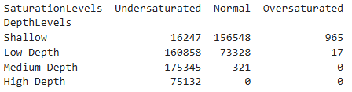
- Expected contingency table:
[[1.12782403e+05, 6.07185773e+04, 2.59020069e+02],
[1.52014140e+05, 8.18397385e+04, 3.49121071e+02],
[1.14019530e+05, 6.13846087e+04, 2.61861300e+02],
[4.87659270e+04, 2.62540755e+04, 1.11997559e+02]]
- Chi-Square statistic:
372123.5178801957
- p-value:
0.0

Insert screenshot of chi-square output
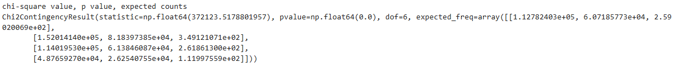
Hint: A post-hoc test may be required to determine a new p-value.

Step 4 – Visualization
Insert relevant plot (e.g. bar chart)
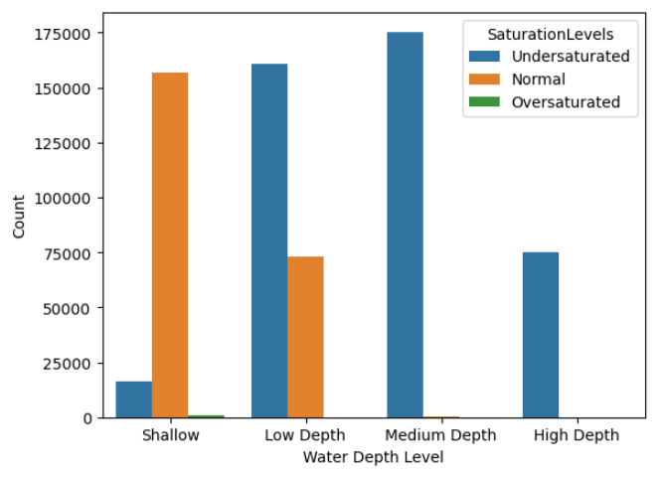

Analytical Reflection (approx. 120-180 words)
- Statistical evidence (Reference chi-square value and p-value.)
We can see initially that the chi squared value is massive. This value sitting at 372,123, indicates a huge difference in predicted vs observed output, and it’s clear when you look at the contingency tables. Primarily, we see that where some saturation readings sit at 0 for some depths, the prediction table has large values. Furthermore, the shallow unsaturated water reading sits at roughly 16 thousand, whilst the prediction says it should be around 113 thousand – a near 100 thousand count difference. These values sit next to the p-value which reads 0. Though this is not the whole story, as the number is more than likely too small to display.

- Interpretation (Explain whether the two variables are statistically related.)
Seeing such a p-value alongside the difference in observed and predicted data, as well as a large chi value, we can very safely accept the alternative hypothesis, that oxygen saturation varies in accordance with the samples’ depth. Something evident in the chart display where we see normal levels taper with depth, giving way to undersaturated levels the deeper we go.

- Impact of preprocessing
The preprocessing may have human error in terms of grouping depths, however, they still come together to show a clear pattern – that the oxygen saturation drops as depth increases.

- Limitation or alternative analysis
The limitation here is that this is only categorical variables – making them less useful for proper scientific analysis, overall however, we can see that the limitations are only minor for the average person’s analysis.

Task 3: Linear Regression

Investigative Question: Does sample density have a relationship with the amount of phaeopigment found in each sample?

Variables Selected:
- Response Variable (Y): Micrograms Phaeopigment per litre seawater (Phaeop)
- Explanatory Variable (X): Potential Density (STheta)

Step 1 - Data Processing Summary (approx. 80 words)
- Filtering applied:
The most stark filtering here would be the selection of data from only 10m depths – this would mean that sample depth would not play a part in the variation of data, deterring randomness in the samples. The set was then dropped to just the two variables, set to numeric to avoid errors. The tail(100) code was also input to give a smaller, more easily readable dataset.
- Missing value handling:
Dropna was done on the dataset, with the two variables being removed if they did not contain any values.
- Rows remaining after cleaning:
100 rows

Insert .head() or summary output screenshot
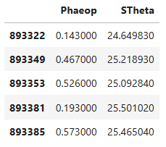

Step 2 – Scatter Plot with Regression Line
Insert scatter plot.
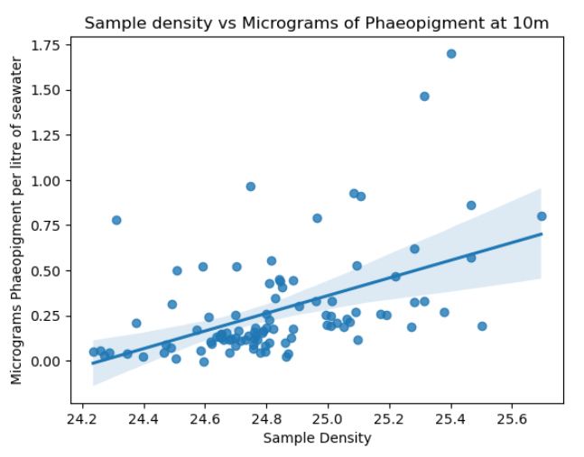

Step 3 – Regression Analysis Results
Regression coefficients:
Intercept (b): -11.8533
Slope (m): 0.4885
R² value: 0.245
p-value: 1.65e-07

Insert screenshot of Regression Analysis output
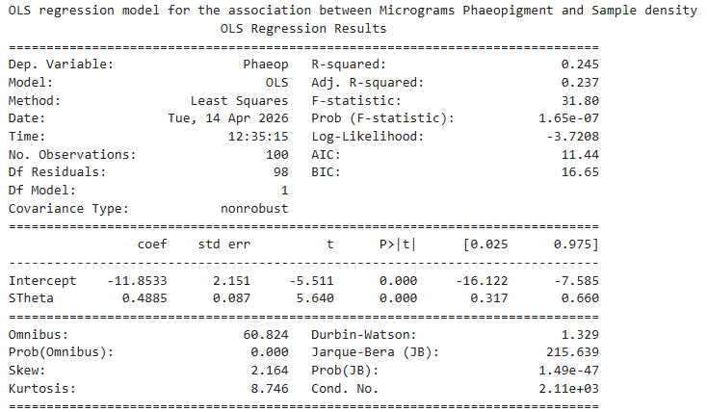

Step 4 – Regression Equation
Y variable = b + m(X variable)
(Micrograms Phaeopigment) = -11.8533 + 0.4885 (Sample Density)

Step 5 – Residual Plot
Insert residual plot
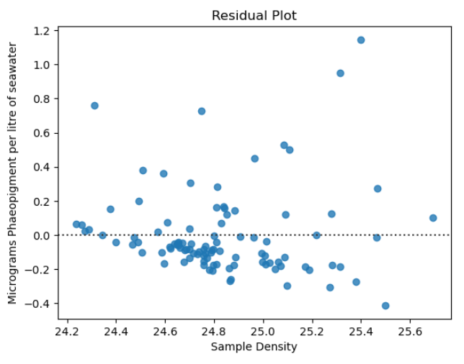

Analytical Reflection (approx. 120-180 words)
- Statistical evidence
Here we see quite a small p-value, sitting at 1.65e-07, whilst a slope of 0.4885 gives an indication on the relationship between variables and the r^2 value tells us about the deviation from the regression line.

- Interpretation
Seeing such a small p-value, we instantly know that the relationship here is not random, however, the r^2 value of just 0.24 takes away from this assumption – depicting a dubious correlation. We can see that the slope of 0.5 does depict a positive relationship; as density increases, so too does the micrograms of phaeopigment, usually. With this evidence in hand, we can safely accept the alternate hypothesis but say that this relationship is quite ‘noisy’ or weak in this instance (as it’s displayed in the residual plot) – we are perhaps not seeing the whole story.

- Impact of preprocessing
Here, preprocessing accounted for the deviation in depth by grabbing samples from only 10m deep. However, more columns may be affecting this relationship – perhaps seasonality, temperature or salinity may also affect these types of readings.

- Limitation or alternative model
To see deeper into this relationship, we would need to include more variables, or preprocess better to limit the effect of other variables – there we may see a starker relationship.

Task 4: Multiple Regression (Advanced Model Design)

This task carries double marks and requires a more advanced level of analysis. You will build a multiple regression model using one response variable and three explanatory variables. Begin by examining the scatter plots between the response and each explanatory variable to identify possible relationships (e.g., linear or curved patterns). Based on these observations, develop a pre-testing strategy to explore different model structures, which may include linear, polynomial, or mixed terms. Test several candidate models, compare their results and diagnostic plots, and then justify the final model you select using statistical evidence and logical reasoning.

Investigative Question:
Does sample oxygen, density, and temperature readings have an affect on the micrograms of phaeopigment in a reading?

Variables Selected:
- Response Variable (Y): Micrograms Phaeopigment per litre seawater (Phaeop)
- Explanatory Variable 1 (X₁): Oxygen Micromoles (Oxy_µmol/Kg)
- Explanatory Variable 2 (X₂): Potential Density (STheta)
- Explanatory Variable 3 (X₃): Recorded Temp (R_Temp)

Step 1 - Data Processing Summary (approx. 80 words)
- Filtering applied:
For the filtering of these 4 variables, all columns were taken from the same month of the year. This would theoretically mean that things like seasonality and effects such as this would be nullified, whilst still giving us access to historical data. The depth was also set at 50m, giving us another nullified variable which could lead to unexplainable outliers and data spread later were it not addressed in the filtering stage.
- Missing value handling:
Dropna was performed on all relevant variables, reducing the probability of errors and 0 values later.
- Any transformations
The values that gave statistical outputs were centred (measured against the mean) for more interesting and possibly accurate readings later in the report.
- Rows remaining after cleaning:
Only 179 rows remained after this cleaning – all from the same month and depth.
- etc.
This data processing should give balanced and reliable insight into how these different variables interact with one another to cause/not cause changes to phaeopigment readings.

Insert .head() or summary output screenshot
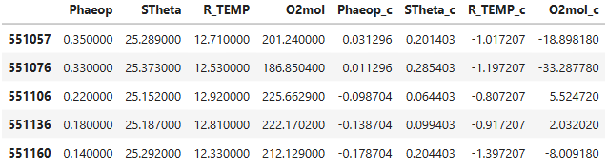

Step 2 – Exploratory Scatter Plots
Create scatter plots between the response variable and each explanatory variable.

Include correlation values (r-value) if calculated.
- Scatter Plot 1 (Phaeopigment vs Density) r²= 0.389
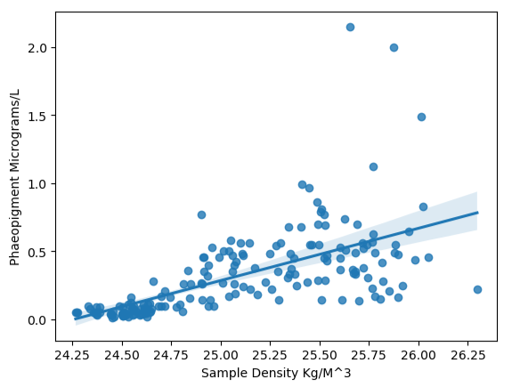
- Scatter Plot 2 (Phaeopigment vs Temperature) r²= 0.369
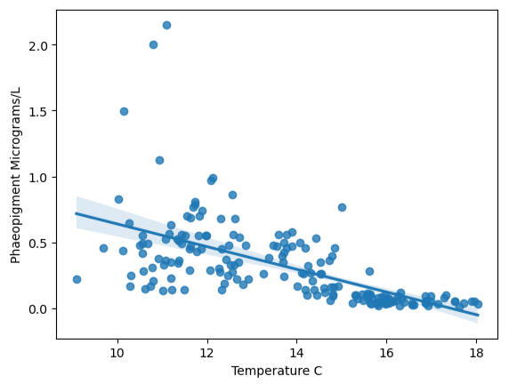
- Scatter Plot 3 (Phaeopigment vs Oxygen) r²= 0.214
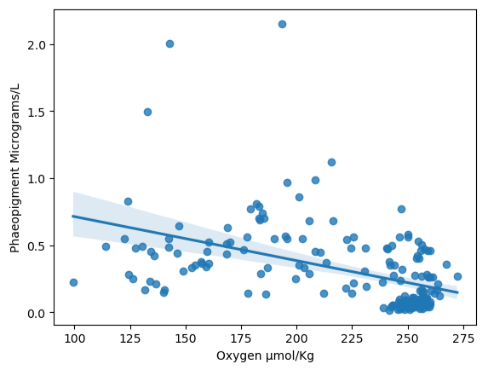

Step 3 – Initial Insights from Scatter Plots
Briefly describe patterns observed.
In these graphs, trends are evident in all three. This is seen in graph 1 as we see a positive correlation between density and phaeopigment – however, the r value seen is of 0.39. This r values indicates that only 39% of the variation in the phaeopigment is explained by the density, and this number only drops as we look to other graphs, with temperature giving a 37%, and oxygen only 21%. In general then we can say that although we can see that even in graphs 2 and 3 (which exhibit a negative correlation), a relationship is seen, these relationships are somewhat weak

Examples of insights:
• Linear relationship
• Curved pattern suggesting polynomial relationship
• Weak/Strong/No relationship
• Possible outliers

Explain how these insights influence your modelling strategy.

Step 4 – Pre-Testing Strategy Plan
Before selecting the final regression model, describe your strategy for testing different model structures. Based on your observations from the scatter plots, you may test combinations such as:
• Linear terms only
• Polynomial terms (e.g., $X^{2}$, $X^{3}$, etc.)
• Mixed models combining linear and polynomial terms

You may also need to experiment with different polynomial degrees (for example, degree 2, 3, or 4) during your pre-testing to determine which form best represents the relationship between variables.

List the possible candidate model structures you plan to test and briefly explain why these combinations were selected based on the patterns observed in the scatter plots.

Model A
Y ~ X1² + X2 + X3
Model B
Y ~ X1 + X2² + X3
Model C
Y ~ X1 + X2 + X3²
Model D
Y ~ X1 + X2² + X3³

These models were selected as individually, each X variable did not hold the strongest of correlations, generally sitting around 30%. So, each should be tested with the variables being individually tested as an order 2 variable to see if more relevant or interesting results are achieved. The final model explores something different, with an order 3 for x3, hopefully giving some alternative dive into the data.

Step 5 – Pre-Testing Regression Results
Run regression analysis for each candidate model.

Insert summary (regression result) outputs.
- Model A summary
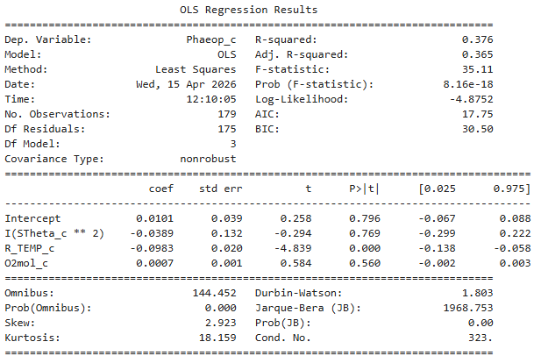
R² = 0.376 / p = 8.16e-18
- Model B summary
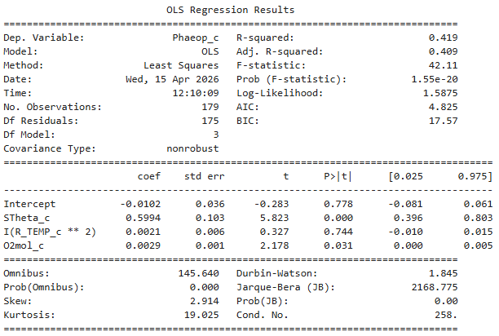
R² = 0.419 / p = 1.55e-20

- Model C summary
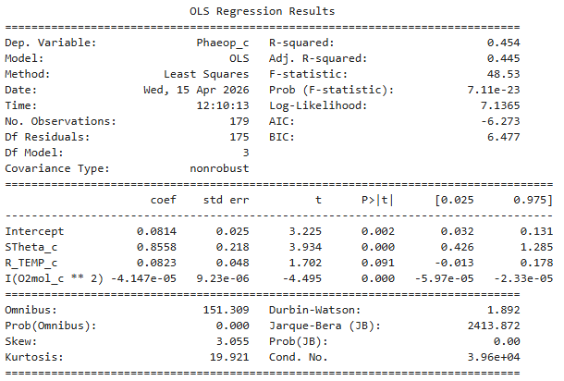
R² = 0.454 / p = 7.11e-23
- Model D summary
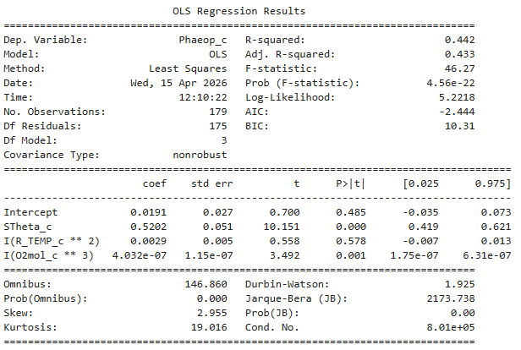
R² = 0.442 / p = 4.56e-22

Step 6 – Pre-Testing Regression Equations
Write regression equations for each candidate model.
- Model A
Y = 0.0101 - 0.0389 X₁² - 0.0983 X₂ + 0.0007 X₃
- Model B
Y = - 0.0102 + 0.5994 X₁ + 0.0021 X₂²+ 0.0029 X₃
- Model C
Y = 0.0814 + 0.8558 X₁ + 0.0823 X₂ - 4.147e-05 X₃²
- Model D
Y = 0.0191 + 0.5202 X₁ + 0.0029 X₂² + 4.032e-07 X₃³

Step 7 – Diagnostic Plots for Candidate Models
Model A Q-Q plot
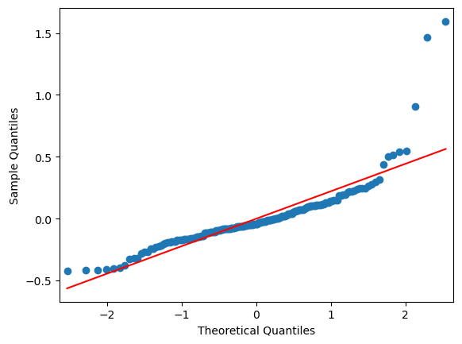
Model B Q-Q plot
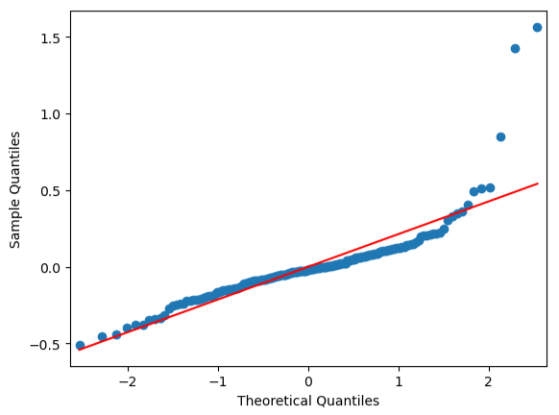
Model C Q-Q plot
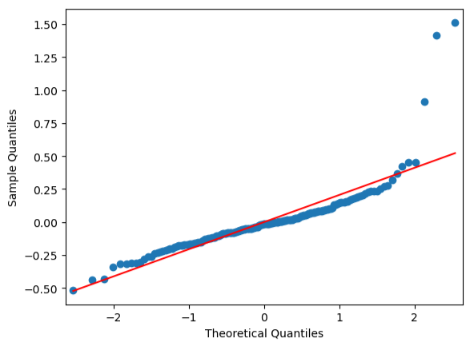
Model D Q-Q plot
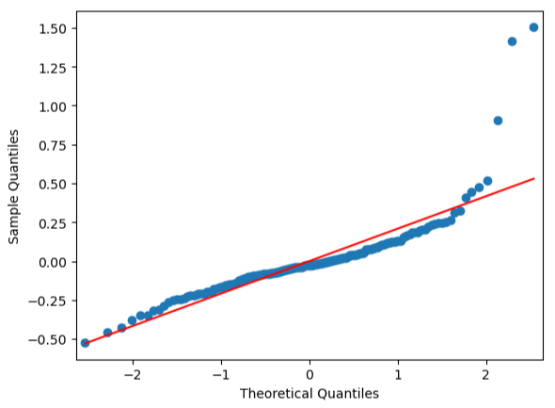

Step 8 – Residual Analysis
Insert standardized residual plots for each model.
Model A
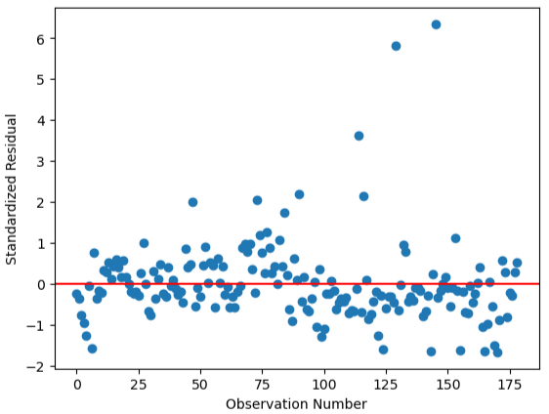
>2std = 3.35195530726257
>2.5std = 1.675977653631285

Model B
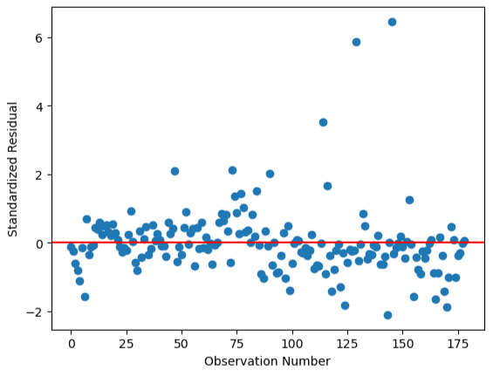
>2std = 3.910614525139665
>2.5std = 1.675977653631285

Model C
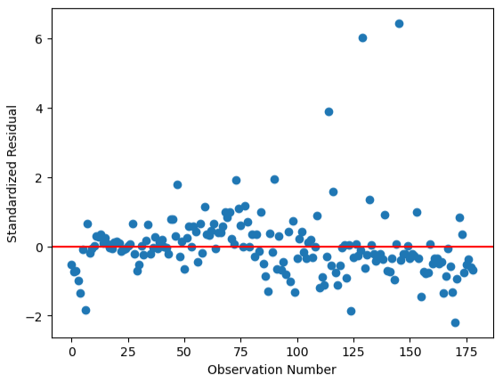
>2std = 2.2346368715083798
>2.5std = 1.675977653631285

Model D
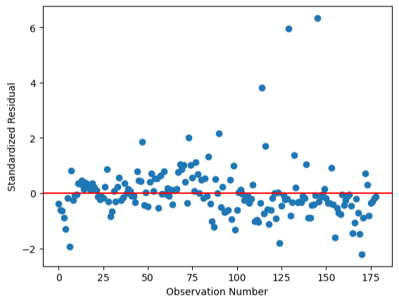
>2std = 3.35195530726257
>2.5std = 1.675977653631285

Briefly comment on residual patterns.
All these residual patterns appear the same at face value. Distribution is borderline identical, and the same outliers appear at approximately the (130, 6) point, explaining the >2.5std deviations. There is quite good randomness here, and the data tends to hold to the line, making all the graphs similar and reasonable as predictions, at least at face value.

Step 9 – Final Model Selection
From your candidate models, select one best model.

Though, as mentioned earlier, when looking at the graphs for these models, they all appear the same, with nigh identical positive relationships, but there are a few small differences that make on stand above the rest. Model C is the most effective predictor in this set of models thanks to its edge in multiple statistics.

Primarily, Model C had the highest r² values, sitting at 45.4% and 44.5%(adjusted). This 0.454 sits 1.2% higher than the next most viable model, and 7.8% higher than the lowest explanation of Model A. Model C also boasted the lowest p-value at 7.11e-23 – so we can be almost certain that the data it depicts is not random. These small but meaningful reading differences make it the most trustworthy in this instance.

Looking at the QQ plots, these also appear nigh identical at a first glance – but looking at the tail of Model C, you may notice (ignoring the 3 outliers found in all plots) that this model does the best job of ‘reigning in’ the tail of the plot. Where the others tails’ push upwards, Model C’s almost pulls back into the regression line – a small but relevant detail.

In the residual plots, this trend continues. Model C does the best job of containing the data near the regression line, and we see this proven by the standard distribution values. As mentioned prior, the same 3 outliers from each plot drive the >2.5 values to hold the exact same numbers amongst all plots, however, when looking at standard distribution above 2 only, we can see that Model C holds the lowest value at 2.23 points as opposed to the rest of the plots, which all have values in the 3’s.

Finally, the model itself is not particularly complicated, only using X3 at a second order to achieve such a reasonable predictive model. This is as opposed to Model D which uses values from the first, second and third order, only to be a worse predictor of our data.

Analytical Reflection (approx. 150-200 words)
- Key statistical evidence
One clearly superior model was still found, and it appeared to display quite clearly with it’s low p-value, and decent r² value, that a relationship is apparent, though somewhat noisy. It is somewhat surprising that bringing the oxygen variable to the second order was relevant as in the standard correlation tests done, it had by far the lowest r² and p-value yet proved to be valuable when changed for the best regression model. This is described more clearly in step 9, with referrals to the data values themselves.

- Interpretation of the selected model
Explain what the model suggests about relationships between variables.
It’s clear that this model indicates a positive correlation, and that density is the primary driver of this relationship between the three variables and phaeopigment readings, with density holding the greatest bearing on the formula coefficients. We can therefore say that as a general rule, oxygen, density and temperature, when combined in a sample, have positive correlation with Phaeopigment readings.

- Impact of preprocessing and modelling choices
Due to the preprocessing, all data was similar environmental factors, which is more than likely what drove all patterns, coefficient values etc. to be quite similar. Hence, the preprocessing gave a more accurate look at the data but doomed the equations, graphs, and regression values to all appear extremely similar.

- Limitation or alternative modelling approach
Perhaps, the values that were used to normalise the data to the same environmental factors could be used differently were the experiment done again. Though I was limited as I used some of these variables in my last report, and so, felt I couldn’t use them in this one, as I had been told. Perhaps comparing these with more fluctuating variables would have given more interesting and differing plots and insights into the Bottle dataset.
To model things better, I did not exploit many of the different degree values. Perhaps using fourth degrees with second degree polynomials in tandem would have gathered more valuable data changes, however, it would be time consuming and possibly using a computer program with more options could be positive were the experiment ran again.

